WORLD l

GROUP 5

ALDREI GLENN NUQUI

1. Get all the list of countries that are in the continent of Europe

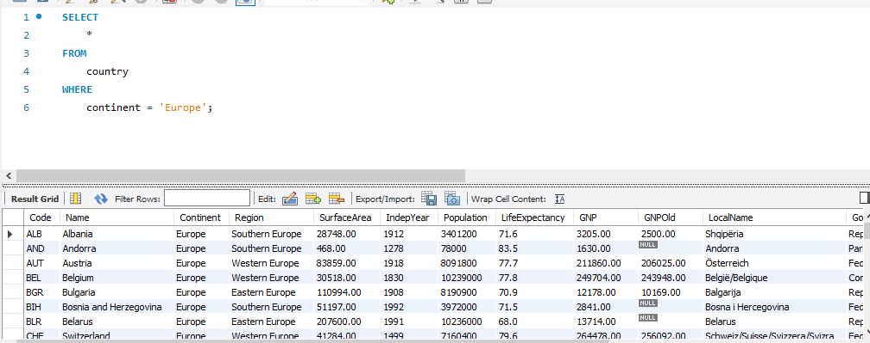

1. Get all the list of countries that are in the continent of North America and Africa

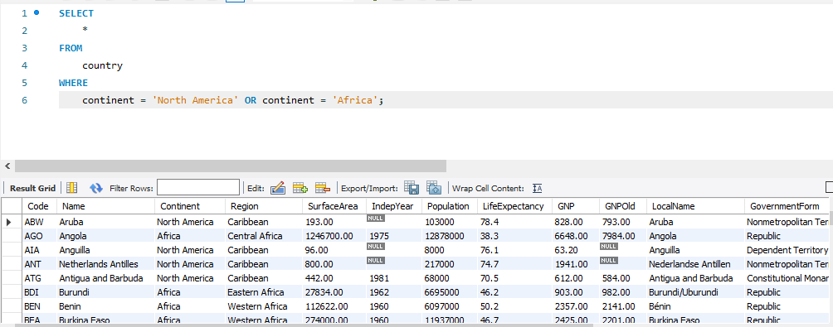

1. Get all the list of cities that are part of a country with population greater than 100 million.

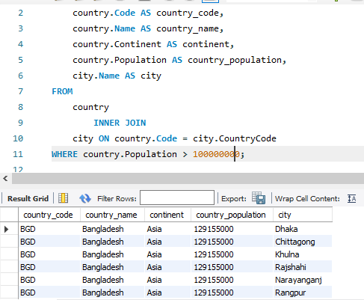

1. Get all the list of countries (display the full country name) who speak 'Spanish' as their language

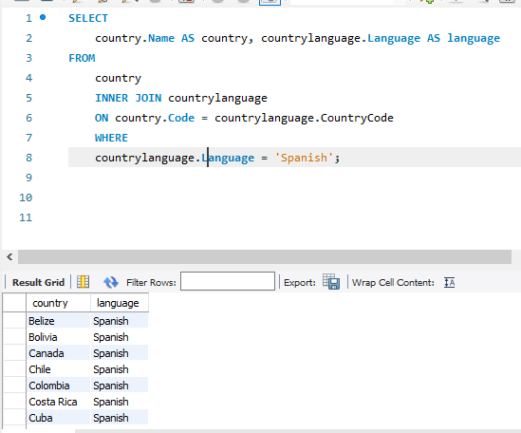

1. Get all the list of countries (display the full country name) who speak 'Spanish' as their official language

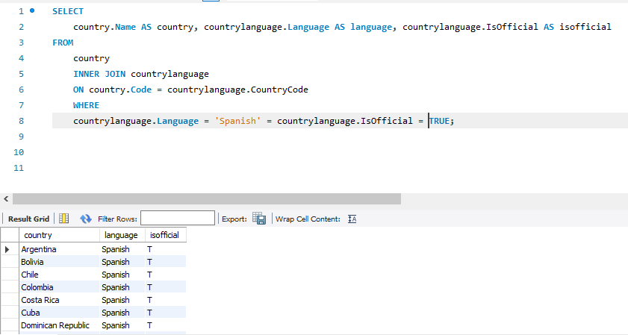

1. Get all the list of countries (display the full country name) who speak either 'Spanish' or 'English' as their official language

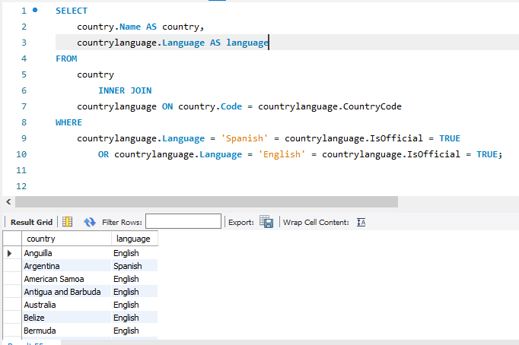

1. Get all the list of countries (display the full country name) where 'Arabic' is spoken by more than 30% of the population but where it's not the country's official language.

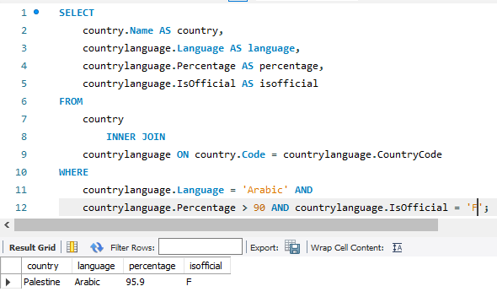

1. Get all the list of countries (display the full country name) where 'French' is the official language but where less than 50% of the population in that country actually speaks that language.

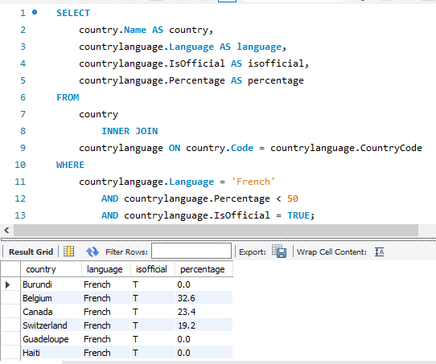

1. Get all the list of countries (display the full country name and the full language name) and their official language.  Order the result so that those with the same official language are shown together.

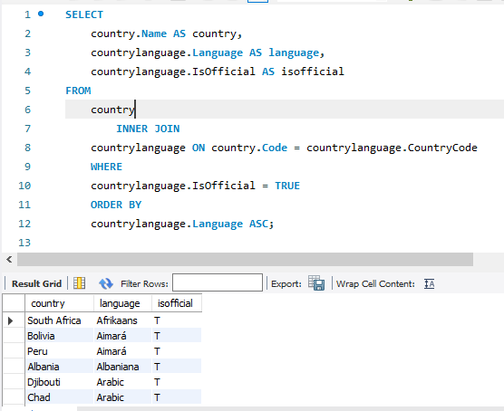

1. Get the top 100 cities with the most population.  Display the city's full country name also as well as their official language.

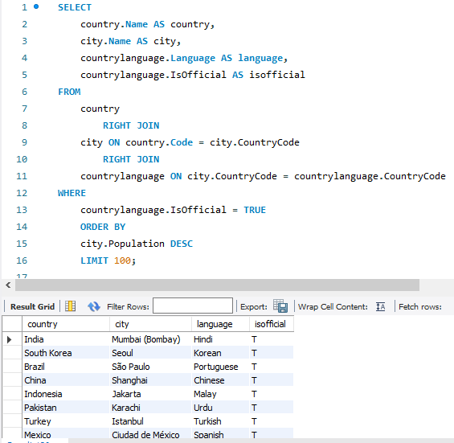

1. Get the top 100 cities with the most population where the life_expectancy for the country is less than 40.

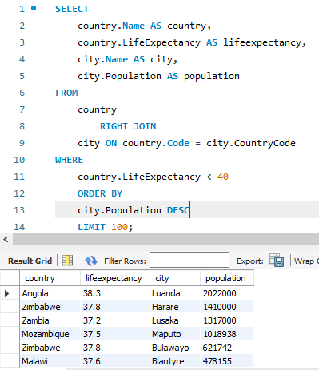

1. Get the top 100 countries who speak English and where life expectancy is highest.  Show the country with the highest life expectancy first.

